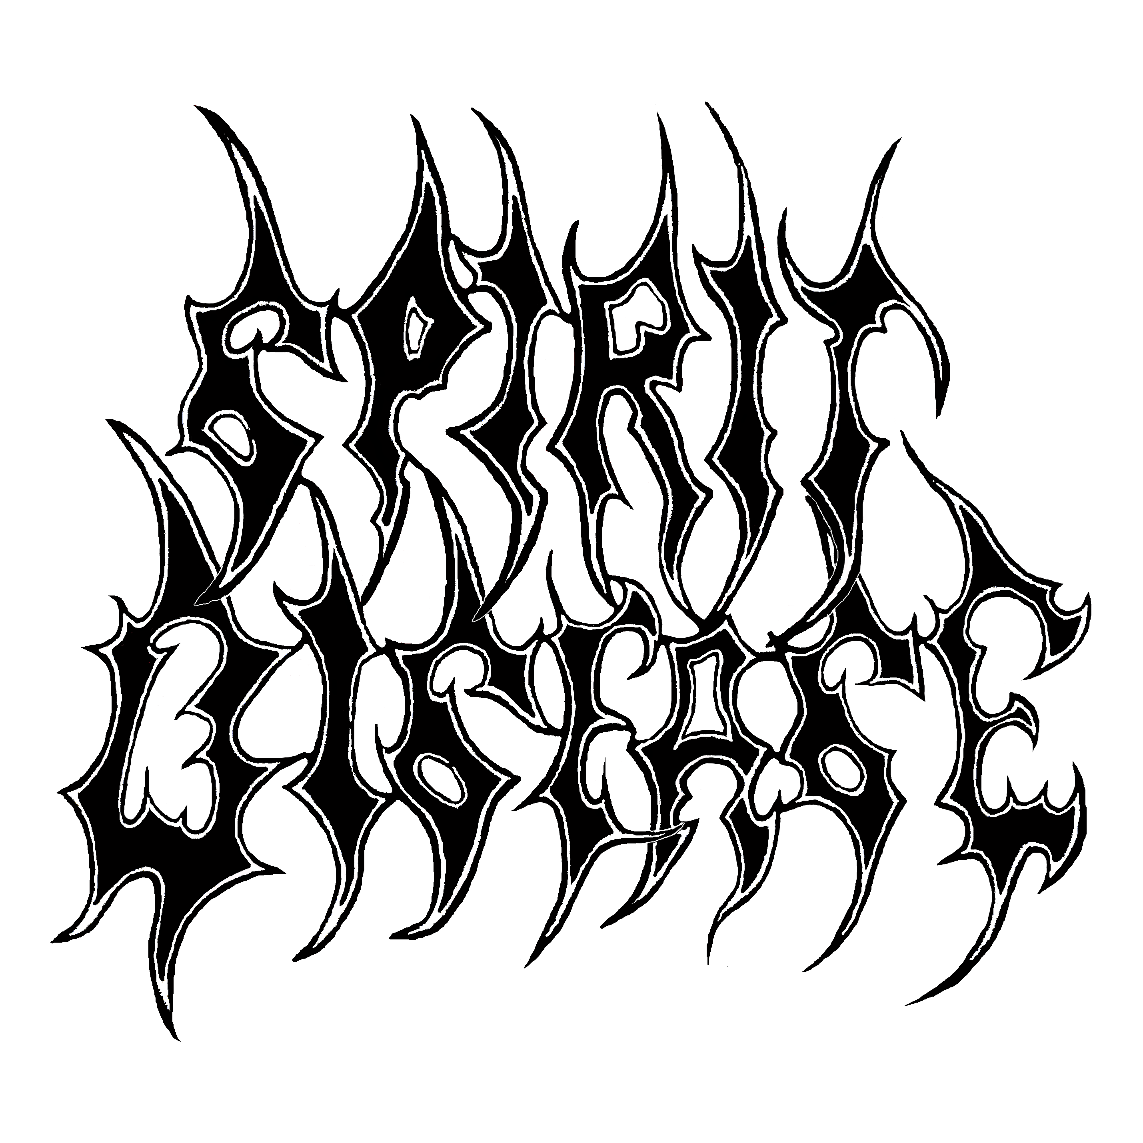
BIOGRAPHY

Spirit Disease was formed in September 2002 by Sallanen. He had been thinking of forming a new band for a really long time, but when things started to go really slowly in his other band due to various other commitments of its other members, he decided that the time was right for a "return to the roots" kind of thing. A few phone calls later the first line-up of the band (now named Spirit Disease) was together: Laukkanen-vocals, Koskinen-guitars, Sallanen-bass & vocals and Tenetz-drums. Rehearsals started, but pretty soon it became obvious that a better drummer was needed, so Tenetz was replaced by Mattila. Couple of weeks later Laukkanen decided to quit for family reasons, so Sallanen took over the lead vocals. These guys were no amateurish beginners in any way. The guys in the band had known each other for over ten years and had played together pretty much all that time in their other projects, playing lots of gigs around Southern Finland. Because of that (not like in most new bands) almost no time had to be spent getting to know each other or learning to play together. The band could concentrate totally into writing and rehearsing new songs.

Spirit Disease is for its members a true return to their roots, a return to the simple, fast and brutal style of music they all used to play back in the late Eighties/early Nineties. Whatever you want to call it then is up to you, but in their noisy songs one can hear obvious Death Metal, Thrash Metal and Grindcore influences.

In June 2003 a noisy and chaotic rehearsal demo was recorded with an old crappy 4-tracker just to get the name of the band known outside their rehearsal place, and to convince a possible new lead singer about the abilities of the band. The entire demo was uploaded on their website and it got a surprisingly good response. The new singer was found soon. An old friend of the rest of the guys, Taskula joined the band in August. He's also known from the band EVEMASTER. He has recorded two CD's with them. The first one was released on KTOK Records and the second one on Low Frequency Records.

The new line-up started rehearsing and songwriting and it was obvious that Taskula's vocals were just perfect for the band. In March 2004 they entered D-Studio to record their debut mini-CD Redemption Denied. The results of the sessions were just excellent, much better than what they had expected. Now the guys had in their hands a really heavy and brutal sounding CD with really good songs. The whole thing was definitely above the usual level of demo bands in general. As a result of this it wasn't released as an "official" demo - instead of that only a small amount of copies were made and sent to record labels.

At the end of May 2004 the line-up of the band was expanded with the addition of a second guitar player, Riikonen. He is an experienced player, like all the other guys of SD. In mid-Nineties he recorded two CD's for Black Mark Productions with his former death metal band SCUM.

Spirit Disease signed a recording contract with Vortex Motions Records shortly after Riikonen's addition to the line-up, and at the moment they are rehearsing and writing songs for upcoming full-length CD release. Their debut MCD will be released during the fall of 2004.

info@spiritdisease.net
http://www.spiritdisease.net

